# Macintosh HD:Users:noemilemonnier:Desktop:Screen Shot 2017-10-20 at 9.03.04 PM.pngCh 8: Trees

# 8.1 Tree

***definition***: abstract model of a hierarchical structure

It consists of ***nodes with parent-child relation***

***Subtree***: tree consisting of a node and its descendants

***Root***: node without parent (A)

***Internal node***: node with at least one child (A, B, C, F)

***External node*** (leaf): node without children (E, I, J, K, G, H, D)

***Ancestors of a node***: parent, grandparent, grand-grandparent, etc.

***Descendant of a node***: child, grandchild, grand-grandchild, etc.

***Depth of a node***: number of ancestors

***Height of a tree***: maximum depth of any node (3)

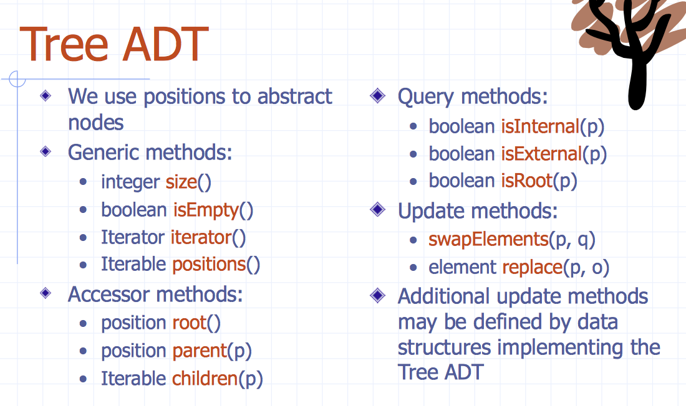

## Macintosh HD:Users:noemilemonnier:Desktop:Screen Shot 2017-10-20 at 9.08.28 PM.png8.1.1 Preorder Traversal

A traversal visits the nodes of a tree in a systematic manner

In a preorder traversal, ***a node is visited before its descendants.***

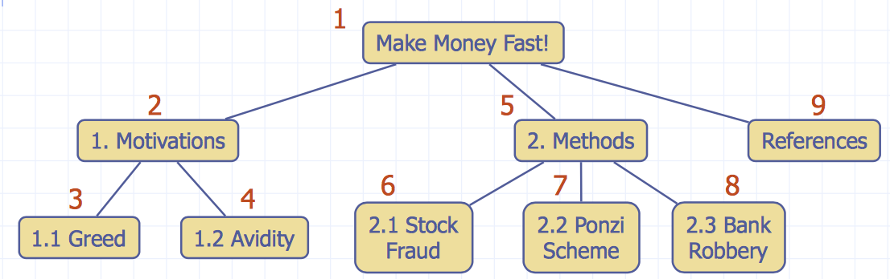

## 8.1.2 Postorder Traversal

In a postorder traversal, a ***node is visited after its descendants.***

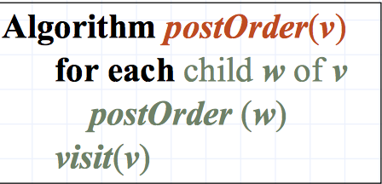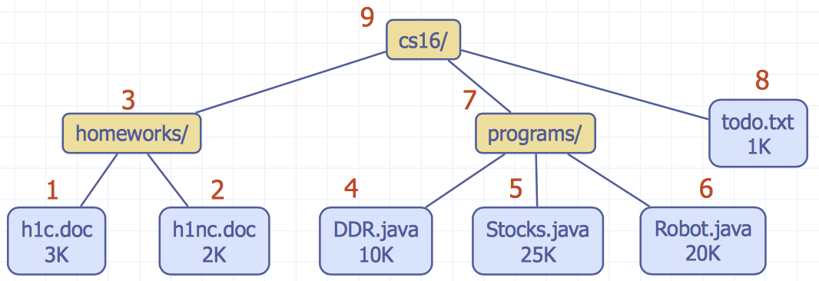

Time taken in preorder or postorder traversal of an n-node tree is proportional to the sum, taken over each node v in the tree, of the time needed for the recursive call for v.

* ***traversal time is O(n)***

# Macintosh HD:Users:noemilemonnier:Desktop:Screen Shot 2017-10-20 at 9.11.41 PM.png8.2 Binary Tree

Properties of tree:

* Each internal node has at most two children (exactly two for proper binary trees)
* The children of a node are an ordered pair

We call the children of an internal node left child and right

child.

***Alternative recursive definition***: a binary tree is either

* a tree consisting of a single node
* a tree whose root has an ordered pair of children, each of which is a binary tree

## 8.2.1 Binary Tree ADT

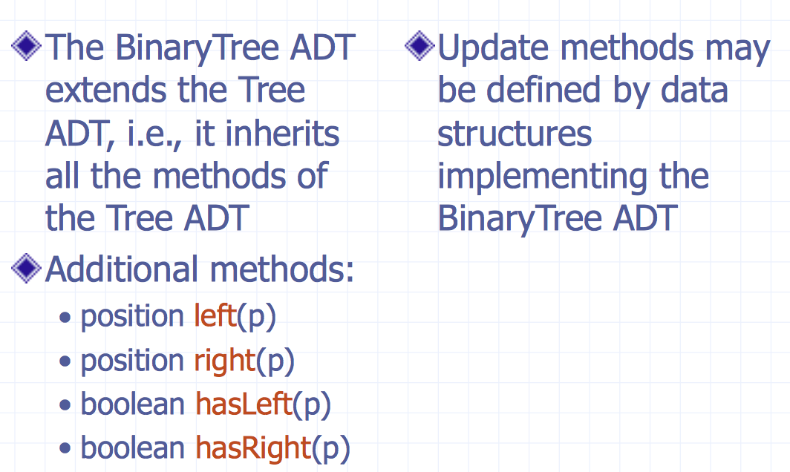

## 8.2.2 Properties of a Proper Binary Tree

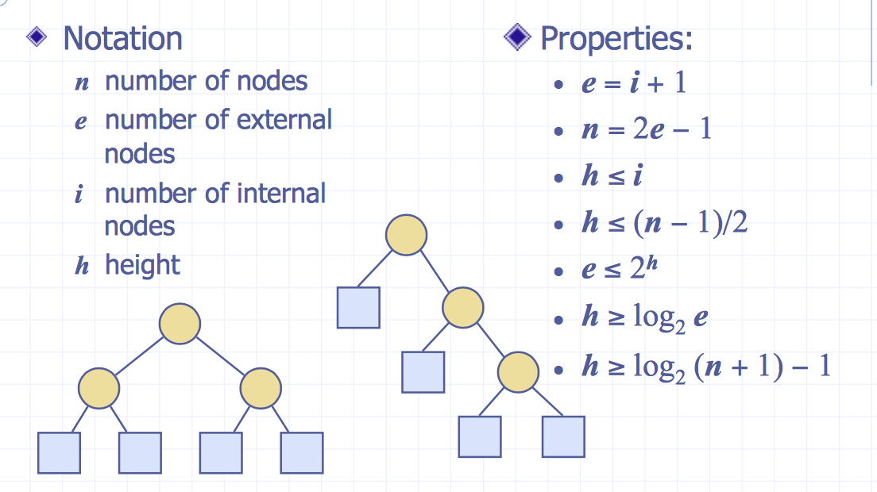

Some proofs:

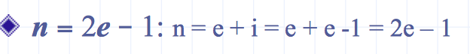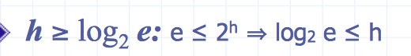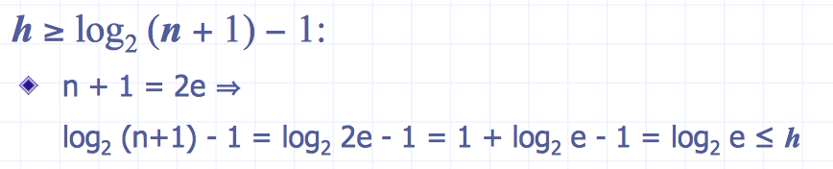

# 8.3 Arithmetic Expression Tree

Binary tree associated with an arithmetic expression

* ***internal nodes***: operators
* ***external nodes***: operands

Example: arithmetic expression tree for the expression (2 × (a − 1) + (3 × b))

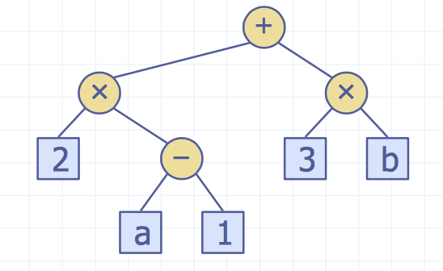

# Macintosh HD:Users:noemilemonnier:Desktop:Screen Shot 2017-10-20 at 9.14.04 PM.png8.4 Decision Tree

Binary tree associated with a decision process

* ***internal nodes:*** questions with yes/no answer
* ***external nodes***: decisions

# 8.6 Inorder Traversal

In an inorder traversal a node is visited after its left subtree and before its right subtree.

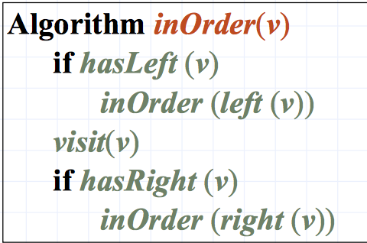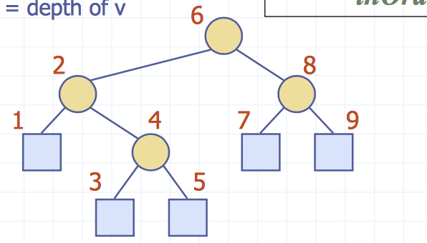

## Macintosh HD:Users:noemilemonnier:Desktop:Screen Shot 2017-10-20 at 9.21.39 PM.png8.6.1 Print arithmetic expressions

Specialization of an inorder traversal

• print operand or operator when visiting node

• print “(“ before traversing left subtree

• print “)“ after traversing right subtree

# 8.7 Euler Tour Traversal

Generic traversal of a binary tree

Includes as special cases the preorder, postorder and inorder traversals Walk around the tree and visit each node three times:

* on the left (preorder)
* from below (inorder)
* on the right (postorder)

## 8.7.1 pseudocode binary tree

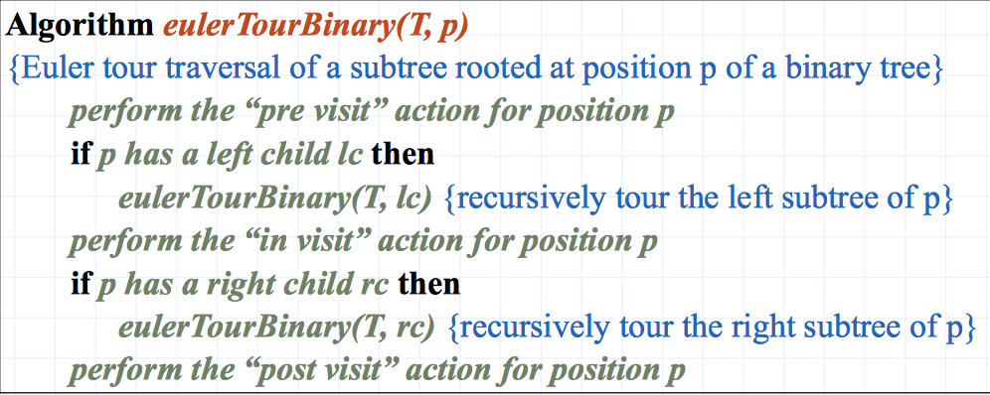

## 8.7.2 pseudocode general treeMacintosh HD:Users:noemilemonnier:Desktop:Screen Shot 2017-10-20 at 9.25.12 PM.png

# 8.8 Linked Structure for Trees

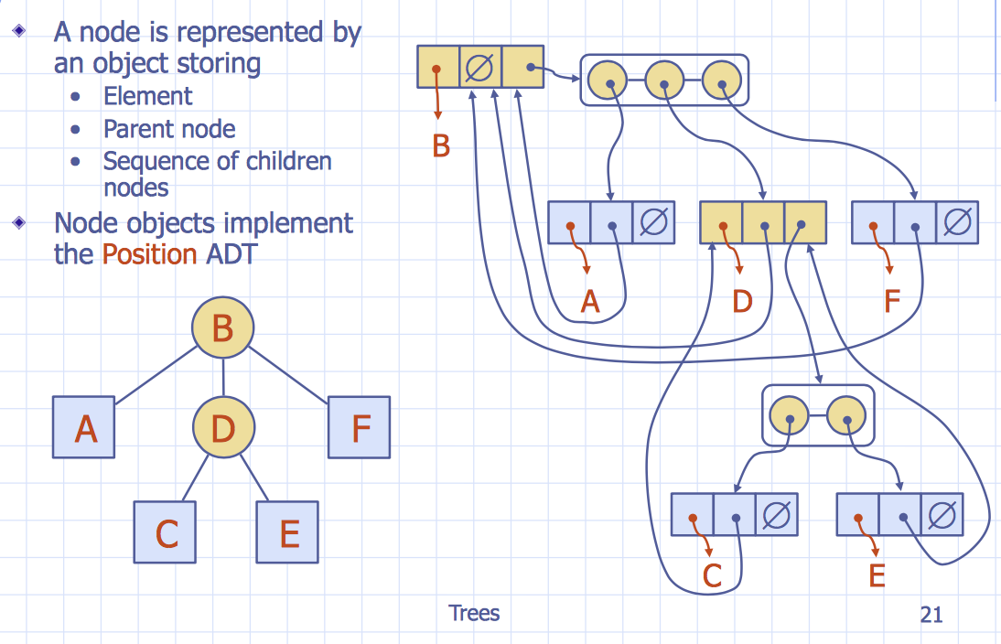

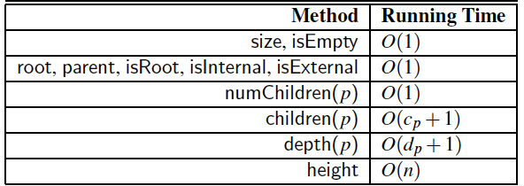

cp denote the number of children of a position p, and dp its depth. The space usage is O(n)

# 8.9 Linked Data Structure for Binary Trees

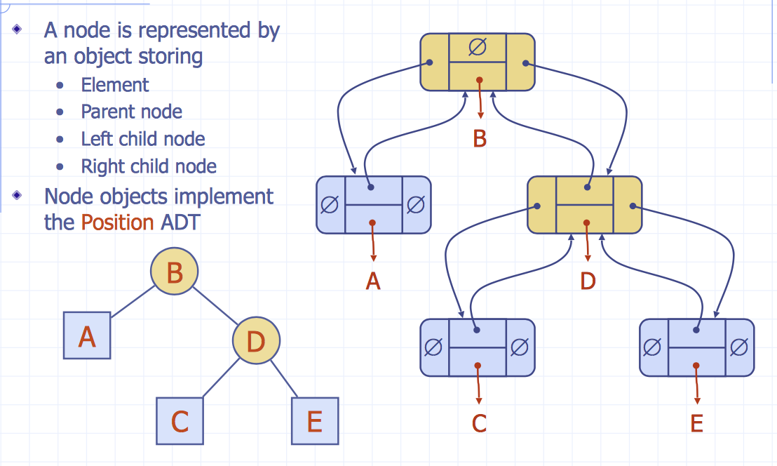

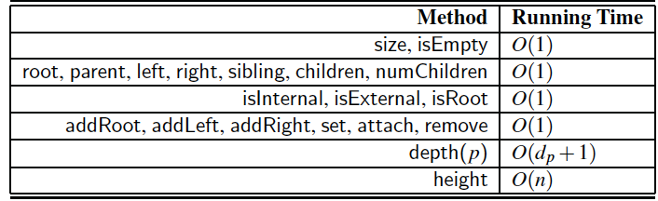

dp is depth

# 8.10 Array-Based Representation of Binary Trees

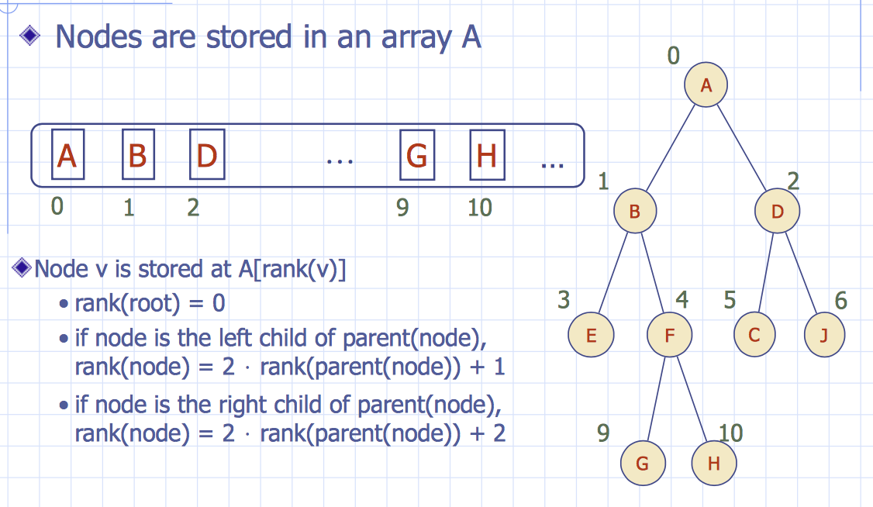

* learn to draw tree from array and vice-versa

# 8.11 Java Implementation

